**Steps for Running SWMM in R**

**Open RSWMM_Autocalibration.R. After opening the code, make sure that “Source on Save” on the upper left is checked.**

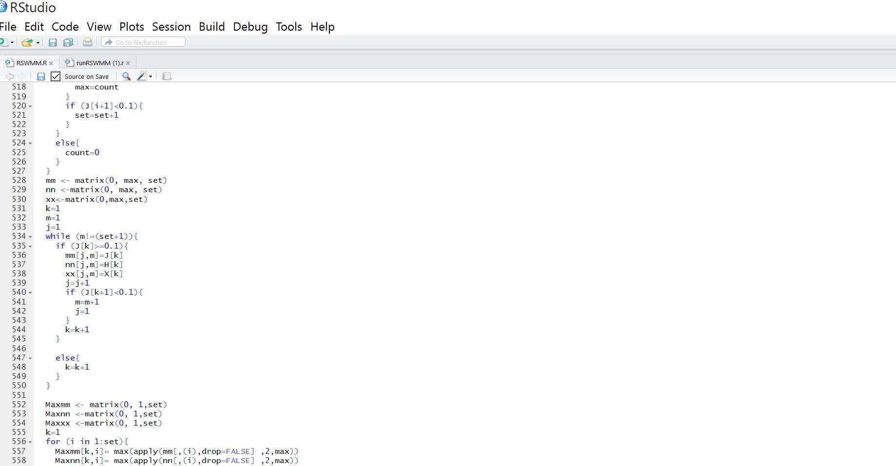

1. **Install the following packages:**

install.packages("ggplot2")

install.packages("stringr")

install.packages("hydroGOF")

install.packages("readxl")

install.packages("xlsx")

install.packages("mco")

library(ggplot2)

library(stringr)

library(readxl)

library(hydroGOF)

library(xlsx)

library(mco)

1. **Make sure the path of Washington_Temp and Washington_dissaggregated in the Notepad DR_Upstream.inp and DR_Opt.inp are correct.**
2. **You need to create the following files as shown in the folder.**

**DR_Upstream_Opt.inp:** This is the file you will number all the calibration parameters as shown in the .inp file.

**ParametersBound.csv:** This is the file you will define initial, upper, and lower boundaries as shown in the CSV file.

1. **Specify iType, vIndex, and nameInOutputFile.**

**iType:**

SUBCATCH=0

NODE = 1;

LINK = 2;

SYS = 3;

**vIndex**

#Code number of each node variable

#0 for depth of water above invert (ft or m),

#1 for hydraulic head (ft or m),

#2 for volume of stored + ponded water (ft3 or m3),

#3 for lateral inflow (flow units),

#4 for total inflow (lateral + upstream) (flow units),

#5 for flow lost to flooding (flow units),

#6 for concentration of first pollutant,

#...

#5 + N for concentration of N-th pollutant.

**nameInOutputFile**

Name of the Node, Outfall, Subcatchment, or Link.

**In this example:**

iType = 1

vIndex = 4

nameInOutputFile = "4"

1. **Provide the path for output file:**

OutFile = "DR_Upstream"

1. **Create an optimization file:**

SWMMOptFile = "DR_Upstream_Opt.inp"

1. **Provide the path for the CSV containing parameter bounds:**

ParametersFile = "ParametersBound.csv"

1. **Provide the path for SWMM executable file:**

swmm = "C:\\Program Files (x86)\\EPA SWMM 5.1.013\\swmm5"

1. **Copy the followings in RSTUDIO workspace:**

iteration = 1

Bounds = ParametersBound(ParametersFile)

initial=c(as.vector(Bounds["Initial"]))$Initial

lower= c(as.vector(Bounds["Minimum"]))$Minimum

upper = c(as.vector(Bounds["Maximum"]))$Maximum

StatParameters = c("NashsutcliffeTimesMinus1", "PercentBias", "linearCorrelationTimesMinus1")

1. **Ctrl+S to save the processes.**
2. **Copy the followings in RSTUDIO workspace**

OptimizationFunction(SWMMOptFile,OutFile,swmm,Timeseries,StatParameters,initial,lower,upper)

1. **After the program is finished running, copy the following lines in RSTUDIO workspace:**

filelist <- list.files(pattern = "^Combinations.*\\.xlsx$")

files <- lapply(filelist, read.xlsx, sheetName = "Sheet1", header=TRUE)

files <- lapply(files, function(x) x[-1])

n= length(data.frame(files))/length(files)

Combination = Reduce(function(...) merge(..., by =1:n, all=T), files)

write.xlsx(Combination, "Calibration Results.xlsx")